library(markovchain)

DriverZone <- c("East","South","West")

DriverZone

[1] "East" "South" "West"

ZoneTransition <- matrix(c(0.1,0.4,0.9,0.3,0.3,0.4,0.6,0.7,0.3),nrow = 3, byrow = TRUE)

ZoneTransition

[,1] [,2] [,3]

[1,] 0.3 0.3 0.4

[2,] 0.4 0.4 0.2

[3,] 0.5 0.3 0.2

ZoneTransition <- matrix(c(0.1,0.4,0.9,0.3,0.3,0.4,0.6,0.7,0.3),nrow = 3, byrow = TRUE, dimname = list(DriverZone,DriverZone))

ZoneTransition

East South West

East 0.3 0.3 0.4

South 0.4 0.4 0.2

West 0.5 0.3 0.2

MCZone <- new("markovchain", states = DriverZone, byrow = TRUE, transitionMatrix = ZoneTransition, name = "DriverMovement")

MCZone

DriverMovement

A 3 - dimensional discrete Markov Chain defined by the following states:

East, South, West

The transition matrix (by rows) is defined as follows:

East South West

East 0.3 0.3 0.4

South 0.4 0.4 0.2

West 0.5 0.3 0.2

class(MCZone)

[1] "markovchain"

attr(,"package")

[1] "markovchain"

#After 2 trips

MCZone^2

DriverMovement^2

A 3 - dimensional discrete Markov Chain defined by the following states:

East, South, West

The transition matrix (by rows) is defined as follows:

East South West

East 0.41 0.33 0.26

South 0.38 0.34 0.28

West 0.37 0.33 0.30

#After 4 trips

MCZone^4

DriverMovement^4

A 3 - dimensional discrete Markov Chain defined by the following states:

East, South, West

The transition matrix (by rows) is defined as follows:

East South West

East 0.3897 0.3333 0.2770

South 0.3886 0.3334 0.2780

West 0.3881 0.3333 0.2786

MCZone^9

DriverMovement^9

A 3 - dimensional discrete Markov Chain defined by the following states:

East, South, West

The transition matrix (by rows) is defined as follows:

East South West

East 0.3888886 0.3333333 0.2777780

South 0.3888890 0.3333333 0.2777777

West 0.3888891 0.3333333 0.2777775

steadyStates(MCZone)

East South West

[1,] 0.3888889 0.3333333 0.2777778

**library**(diagram)

Loading required package: shape

#plot

plot(MCZone)

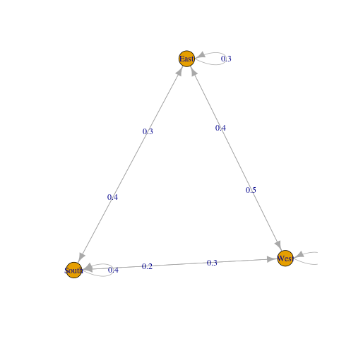

row.names(ZoneTransition) <- DriverZone; colnames(ZoneTransition) <- DriverZone

plotmat(ZoneTransition,pos = c(1,2),

lwd = 1, box.lwd = 2,

cex.txt = 0.8,

box.size = 0.1,

box.type = "circle",

box.prop = 0.5,

box.col = "light blue",

arr.length=.1,

arr.width=.1,

self.cex = .6,

self.shifty = -.01,

self.shiftx = .14,

main = "Markov Chain")

